PPILOGOHERMA Building

94 Scout Rallos StreetKamuning, Quezon CityPhilippines

Telephone: (632) 922-3421

Facsimile: (632) 929-4687

December 17, 2023

**LETTER OF PROTEST**

Flowrate discussed vs Actual Flowrate

Attention : MT Kirana Quartya

Voyage Number : v53/23

Discharging Port : Chevron Batangas Terminal

This is to put you on notice regarding the difference of flowrate discussed versus the actual flowrate of IFO180 and IFO 380.

Please refer to table below.

This serves as our letter of Protest against any cause regarding discharging time.

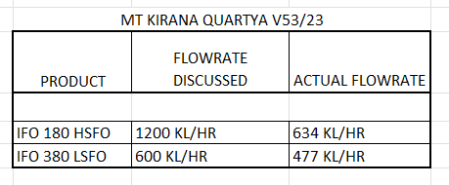

For your reference, attach here also is the document of terminal regarding flowrate during predischarging meeting.

RONNIE Q CUSTODIO

Petrotrade Phils Inc

Consignee